Lesson Plan 1
Lesson 1: Introduction to Roblox and Basic Tools (2 hours)

Roblox Cinematic Trailer (5 minutes)
We'll start the class with a screening of an engaging cinematic trailer for Roblox to capture the students' interest.
Video Link: https://www.youtube.com/watch?v=wBYjsROAy5w

Introduction to Roblox (2 minutes)
Roblox is a vast platform that includes Roblox Studio, a tool that allows anyone to create games within this framework. Game creation encompasses two aspects: 3D modeling and programming. We will be adding 3D objects, configuring them, and writing code to program their behavior.
For those already familiar with Scratch, the process will be similar. We'll add objects to the scene and code how they should behave. However, there are some key differences. For one, we don't need to write code for the player; Roblox takes care of that, such as movement and jumping. The second significant difference is that we operate in a three-dimensional space.
Here we can pose several questions to engage with the children. For example,
- What is three-dimensional space?
- What kind of space was in Scratch?
- How is the space in Scratch different from the space in Roblox?
Ultimately, we should establish that a three-dimensional space is one where, in addition to the two dimensions we know from Scratch - length and width - there is an added one: height.

Course Overview (2 minutes)
We'll discuss the course structure and what the students will be learning.
Course Content:
- Brief introduction to Roblox and its capabilities in the realm of game development and creativity.
- Fundamentals of 3D modeling and programming within the context of Roblox.
- Practical exercises and homework assignments aimed at reinforcing acquired skills.
- Projects for Skill Development
- Independent Project to be Presented at the End of the Course
How it will be organized:
- Each lesson will consist of a theoretical part, practical exercises, and homework assignments.
- Some lessons will be dedicated to studying specific tools and techniques, while others will focus on project development and the practical application of acquired skills.
What you will gain:
- Practical skills in game development on the Roblox platform.
- Understanding the fundamentals of programming and 3D modeling.
- A portfolio of projects that you can present at school, to future employers, or use for further learning.

Introduction (10 minutes)
We'll start with the instructors: Each takes turns introducing themselves, mentioning their hobbies, and favorite games on Roblox. Optionally, to make it more interactive, you can use a ball, a soft toy, or any other light object and throw it to the children when it's their turn to talk about themselves. After speaking, they throw the object back to the instructor, who then throws it to another student.

Creating a New Project (3 minutes)
We'll teach students how to create a new project.
Steps for creating a new project in Roblox Studio:
- Open Roblox Studio
Launch the program and click on "New" to start a new project.
- 2. Choose a Base Template
Since we'll be working with the "Baseplate" template, select it from the list of templates.
- 3. Saving the Project
The method of saving depends on your needs and plans:
- Save To File: Save the project on your local computer. This method is useful for quick tests and iterations that you don't want to publish online yet.
- Save to Roblox: Save the project on Roblox's servers. This allows access to the project from any computer and enables collaboration.
- Publish to Roblox: Publish the project on the Roblox platform, making it accessible to all users. This method not only saves your project but also publishes it for a wide audience.

Setting Basic Parameters:
Enter the project name, add a description, and specify tags to facilitate the search and identification of the project.

Camera Management in Roblox Studio (5 minutes)
Basic Camera Functions:
- Panning: Move the camera left, right, up, and down.
- Zooming in and out: Change the scale of the space.
- Rotation: Rotate the camera around the axis for different perspectives.
Keys and Combinations for Camera Control:
- Camera movement: keys W, A, S, D.
- Zoom in and out: mouse wheel.
- Rotation: hold the right mouse button and move the mouse.
- Move up and down along the Z-axis: keys Q and E.
Camera Modes and Hotkeys:
- Free Camera (Shift + F): Full control, allowing movement throughout the space.
- Fixed Camera (Shift + G): The camera locks onto a specific object or coordinate.
- Tracking Camera (Shift + T): The camera follows a moving object.

Exploring Roblox Studio Zones (10 minutes)
We will briefly introduce all the working zones in Roblox Studio and explain their functions

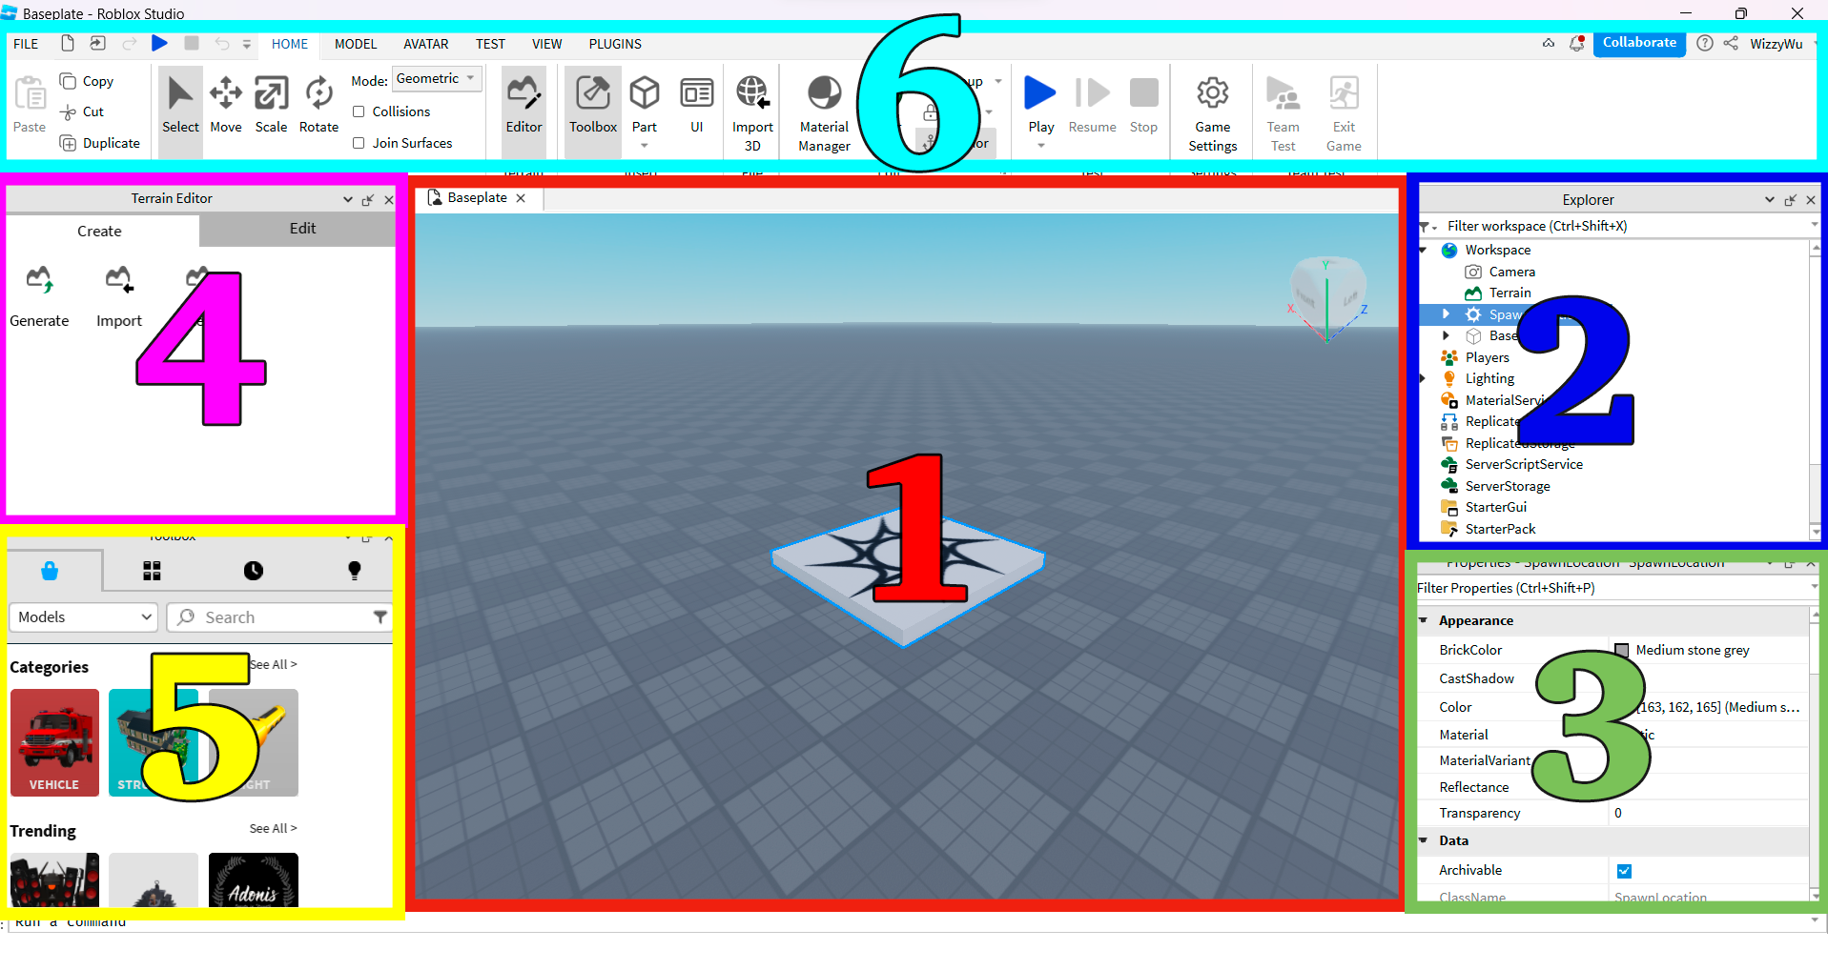
1. Viewport (Working Space):
Main Purpose:
The viewport, or working space, is the central zone in Roblox Studio where developers visualize and interactively work with objects and scenes. This is the primary area where you will spend most of your time, adjusting game elements, placing objects, and testing various mechanics.
Features and Functions:
- 3D Visualization: Provides a three-dimensional space for placing and manipulating objects.
- Scene Testing: The viewport allows for quick launching of a game or scene for testing, enabling you to assess how everything will look and function in real-world conditions.
- Context Menus: Right-clicking opens a context menu with various options such as copy, paste, delete, and other object parameters.
- Navigation and Scaling: Use of mouse and keyboard for navigation (W, A, S, D for movement, Q and E for moving up and down along the Z-axis) and scaling (mouse wheel).
- X, Y, Z Axes: Ability to see and work with three-dimensional axes, facilitating the understanding of spatial relationships between objects.
- Object Selection: Left-click for selecting a single object, Shift + Left-click for selecting multiple objects.
- Multiple Viewing Modes: Toggle between different viewing modes such as side view, top view, bottom view, etc., for more detailed work.
- Camera Operation: Ability to change camera positioning for better viewing and interaction with objects. Various camera modes like free, fixed, and tracking are available for more convenient work.
In summary, the viewport is the heart of Roblox Studio and the key area for all kinds of development and testing. It's the place where your creativity and technical skills come together to turn your concept into a real game or project.

2. Explorer
The Explorer panel is one of the most important tools in Roblox Studio. It provides a hierarchical view of all objects and components present in your game world, including models, parts, scripts, and even minute elements like fire or effects.

Main Features and Benefits:
- Navigation: Easily move between different elements of your project.
- Organization: You can drag and drop objects to change their location in the hierarchy, group them together, or nest objects within others.
- Quick Access to Properties: Clicking on any object gives you access to its properties in the Properties panel.
- Script Management: All scripts associated with an object will also be displayed in this panel, simplifying the coding process.
- Search: The ability to quickly find a needed object if you have a large project with multiple elements.
Using the Explorer panel significantly simplifies the development process, making it more organized and intuitive.

3. Properties
The Properties tab in Roblox Studio is the place where you can fine-tune each object in your project. This can range from fundamental characteristics such as size and position of the object to more specific ones like material, color, transparency, and much more.

Main Features and Benefits:
- Flexibility: Allows for detailed settings for each object, making your game unique.
- Interactivity: Settings can be changed in real-time, letting you immediately see how changes impact the object.
- Easy Access: Available right next to the Explorer tab, ensuring quick and effortless access to settings.
- Ease of Use: The interface is fairly straightforward and intuitive, even for beginners.
Using this panel makes the development process more controllable and allows for easy adjustments to various aspects of your game or scene.

4. Terrain Editor
The Terrain Editor is designed for creating and editing landscapes and natural features in your game. Here, you can add hills, valleys, rivers, and other natural elements.
Tools and Functions:
- Addition and Deletion: Tools for adding or removing terrain.
- Leveling and Smoothing: Tools that allow you to smooth or level the surface.
- Painting and Materials: Provides the opportunity to add various textures or materials to the terrain, such as grass, sand, or snow.
- Water: A tool for adding water features like rivers and lakes.
Control Panels:
- Settings: Here, you can configure parameters such as brush size or effect intensity.
- Region: Allows you to select a specific area of the terrain for more detailed work.
Note: When working with the Terrain Editor, it's important to consider the possible impact on performance, especially when working with large and complex landscapes.
This area is key for creating engaging and realistic game worlds, and it offers numerous tools for fine-tuning the landscape.

5. "Toolbox"
The Toolbox tab in Roblox Studio provides an extensive library of assets, created by both Roblox Corporation and the developer community. This is a place where you can quickly find and add various objects, scripts, sounds, and even entire models to your project.
Main Features and Benefits:
- Quick Start: Reduces development time by providing ready-to-use resources.
- Variety: A vast collection of different assets, from simple blocks to complex scripts.
- Search and Filters: Intuitive search tools and filters help you quickly find the elements you need.
- Integration: All items added via the Toolbox automatically appear in your Explorer, and their properties can be configured in the Properties panel.
Using the Toolbox significantly simplifies the development process, allowing you to focus on the creative aspects of your project, rather than building every element from scratch.

6. "Ribbon Menu"
The "Ribbon Menu" tab is located at the top of the Roblox Studio interface and serves as the control center for your entire project. This ribbon contains a series of tabs, each offering different tools and functions.
Let's take a closer look at each tab in the Roblox Studio Ribbon Menu:
- Home: This tab is grouped for quick access to the most commonly used tools from other tabs. Here you can find basic editing tools like copy, paste, cut, and delete, as well as tools for grouping and distributing objects.
- Model: This tab is designed for working with 3D objects. Here you will find tools for moving, rotating, and scaling objects. It also includes more advanced tools like Union and Negate for creating complex shapes.
- Avatar: Here you can configure the appearance and functionality of the avatar in your game. This includes selecting clothing, accessories, and other parameters.
- Test: This tab provides various tools for testing your game within Roblox Studio itself. You can run the game with different settings and in various modes to check its functionality.
- View: Here you can toggle different panels and workspaces, such as Explorer, Properties, and Output. This helps you customize the Roblox Studio interface according to your preferences.
- Plugins: This tab is intended for managing installed plugins. You can activate, deactivate, or delete plugins, as well as find new ones in the plugin store.
Each of these tabs has its own sub-menus and additional options, providing flexibility and a multitude of possibilities for developing your game or project.

Break (10 minutes)

Creating a Simple Game Without Code (40 minutes)

Game Description:
We will be creating a simple game—a platformer. The goal of the game is to reach the final platform by overcoming all obstacles, jumping from one platform to another. If the character falls, they die and start over.
Our aim in this game is to introduce children to some of the tools. We will be working with the Modeling tab and will explore some tools that will help us work with models.

Project Preparation:
Create a new project based on Baseplate.
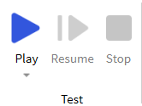
Let's get it running by using the Play button.
We can ensure that when launching the game, our character can freely move around the game space. To start, we need to remove the surface. We'll select the "Baseplate" object in Explorer and delete it. To verify, let's run the game again. Now our character falls, dies, and then respawns. However, the fall takes a long time.
We can fix this by setting a specific height at which objects, including characters, will be destroyed. To do this, we'll select "workspace" and find the property "FallenPartsDestroyHeight". We'll change its value; for example, setting it to -10 or -30 will result in faster character death. It's important to remember that to save these changes and have them affect the game, you must stop the game, make the changes, and then run it again.

So, if a character falls 30 units below the starting level, they will be destroyed. This rule applies not only to characters but also to all other objects.

Testing
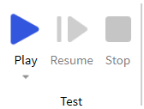
Button "Start"
What it does: When you press this button, the game launches within the Roblox Studio environment. This allows you to personally navigate through the levels and check how the environment you've created behaves, including objects, scripts, and other elements.
Button "Stop"
What it does: Stops the execution of the game and returns you to the editing mode in Roblox Studio.
Button "Resume"
What it does: If you have paused the game, this button allows you to continue testing from where you left off.
Important Warning
If you make any changes or add new elements during testing, they will be displayed in real-time. However, when you stop testing and return to editing mode, these changes will not be saved.
Making changes during testing can result in the loss of those changes and, consequently, the loss of time. Therefore, it's very important to refrain from editing the project while active testing is ongoing.

Key Tools:
In this section of the lesson, the teacher will use various tools and functionalities of Roblox Studio to create a game route. We won't provide strict step-by-step instructions here, as that is at the teacher's discretion. Instead, we will focus on describing key tools, objects, and their applications, with which the teacher should acquaint the students.

Spawn Location Setup:
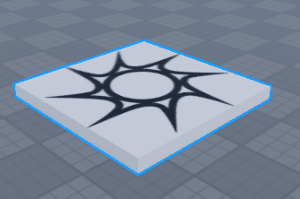
The "Spawn Location" object in Roblox Studio is a specialized platform where game characters appear ("spawn") at the beginning of the game or after respawning. These points are usually placed in key areas of the game map for player convenience.
It can be added in two ways: either through the "Model" tab, where there is a corresponding button
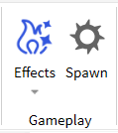
Or through the "Toolbox" area, which also features a collection of various objects, including "Spawn Location".
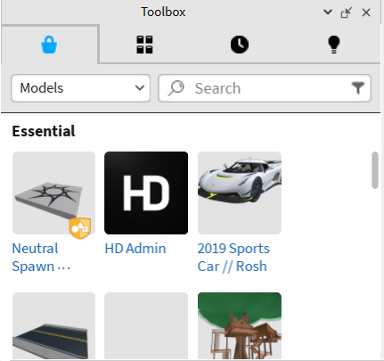
Main Features:
- Size and Shape: You can customize the dimensions and shape of the platform based on the specific needs of your game.
- Orientation: Using object properties, you can set the direction in which the character will face after spawning.
- Respawn Timers: Allow you to set time intervals between possible spawn moments for characters.
- Team Binding: If there are different teams in the game, you can set different spawn points for each of them.

Changing the Background:
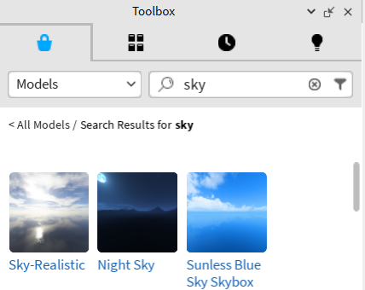
Roblox Studio offers the option to change the background of the game world, adding atmosphere to your project. To do this, simply enter the keyword "Sky" into the collection search bar. This will present you with various sky background options, including cosmic themes. This is a great opportunity for a small experiment: let the children choose the background that inspires them the most.

Adding Objects:
Part Button:
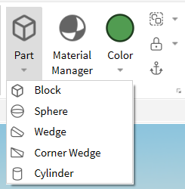
Located on the "Model" tab, it allows you to add basic geometric shapes, such as cubes, spheres, wedges, and cylinders.
- Cube (Block): This is the most basic object. It can be used for creating walls, floors, or any other structures. Key properties include size, color, and material.
- Sphere: Perfect for creating round objects.
- Wedge: Useful for creating inclined surfaces. They can be combined with cubes to create complex shapes.
- Cylinder: Ideal for creating columns or pipes.
Using Collections:
Toolbox: This is where you can find various pre-made objects, scripts, and resources. To add an object, simply drag it onto the scene or double-click on it.

Working with 3D Tools (Moving, Scaling, Rotating, Transforming):
Let's explore the tools in the "Model" tab under the "Tools" section.
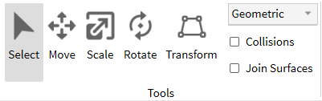

Main Tools:
- Select: This tool allows you to select one or multiple objects within the scene. Once objects are selected, their properties will be displayed in the properties panel, enabling easy modification. You can use this tool for group movement, rotation, or scaling of objects.
- Move: Enables you to move objects along the X, Y, Z axes. Each axis has its own color indicator.
- Scale: Alters the size of an object along specified axes. You can enlarge or shrink an object without changing its shape.
- Rotate: Allows you to rotate an object around its center. Rotation can also be limited to one or multiple axes.
- Transform: This is a more advanced tool that combines the capabilities of moving, scaling, and rotating in one. Usually, Transform is represented as a set of axes and planes along which you can move, scale, or rotate the selected object.
Geometric and Physical Methods for Working with 3D Objects:
Geometric Method: In the geometric approach, you deal with objects as a set of coordinates and shapes. This approach ignores physical properties like mass, friction, or gravitational force.
- Physical Method: The physical method involves using physical laws to model object behavior. This means mass, friction force, gravity, and other physical parameters will influence how objects interact with each other and the environment.
Behavioral Differences:
- In the geometric method, all changes are "absolute" and independent of the environment.
- In the physical method, changes are "relative" and dependent on various factors such as gravitational force or object mass.
Collision and Join Surfaces Options:
Collisions: This option allows objects to collide with each other. If disabled, objects will pass through one another.
Join Surfaces: This option allows you to join surfaces of different objects, making them a single entity.

Anchoring Objects:
Anchoring objects is an essential part of the process of creating stable and functional 3D models in Roblox Studio. This process prevents unwanted movement or falling of objects in the game world, especially when interacting with players or other objects.
How to Use the Anchoring Feature:
- Through Object Properties: You can select the desired object and change the "Anchored" property in the properties panel.
- Through the Interface: In some cases, especially in collaborative editing mode, it's convenient to use interface tools for quickly anchoring objects.
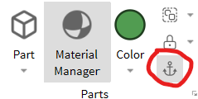
Unanchored Objects and the FallenPartsDestroyHeight Mechanic:
If an object in Roblox Studio is not anchored (the "Anchored" property is set to false), it follows the laws of physics, including gravity, and will begin to fall downward until it collides with another object or reaches a certain height. This "critical" height is defined by the FallenPartsDestroyHeight property in the Workspace.
How FallenPartsDestroyHeight Works:
- This numerical value sets the "height" (or depth, if referring to negative values) at which objects will automatically be removed from the game space.
- This feature is useful for optimizing performance and preventing unnecessary load on the game. For example, if players or objects fall into an infinite abyss, they will not "linger" in memory, consuming resources.
- To change this value, go to Workspace, find the FallenPartsDestroyHeight property, and set it to the desired number. This can be useful if you want characters or objects to fall for a longer or shorter time before being removed.
Examples:
- If FallenPartsDestroyHeight is set to -10, any unanchored object or character reaching this mark will be automatically deleted.
- You can use this property to create "traps" or hazardous areas in the game where characters will "die" upon reaching a certain depth.

Object Appearance:
In Roblox Studio, you can easily modify the appearance of game objects to make your world more unique and interesting. This can be done using several tools and options available within the program itself.
Changing Colors:
- Through the Properties Panel: Once you select an object, go to the Properties panel and find the "Color" section. Click on the color field, and you'll be prompted to choose a new color from the palette.
- Through the Model Tab: In the "Model" tab on the toolbar, there are also options for quickly changing the color of a selected object.
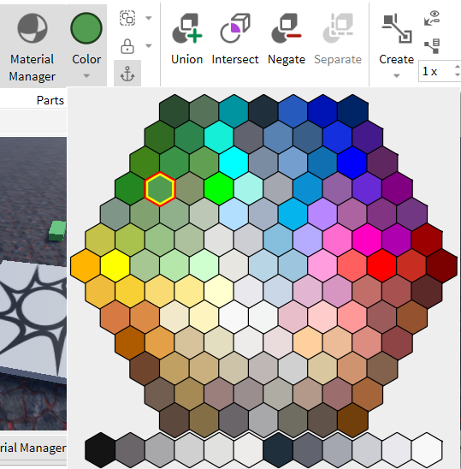
Changing Material:
- Through the Properties Panel: In the same Properties panel where you changed the color, you'll find the "Material" option. Choose from the dropdown list the desired material—be it wood, metal, or something else.
- Through the Model Tab: You can also change an object's material using the corresponding options in the "Model" tab.
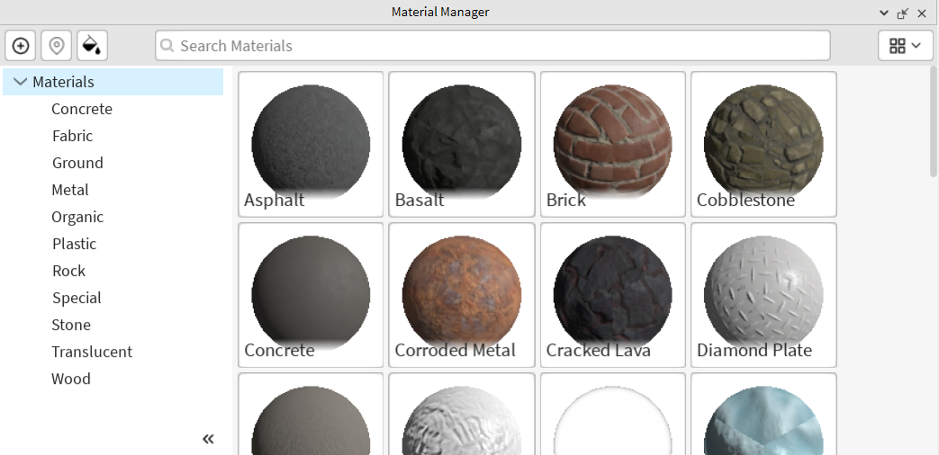

Object Transparency:
- Through the Properties Panel: If you want to make an object semi-transparent or fully transparent, use the "Transparency" property in the Properties panel. You can set the value in a range from 0 (fully opaque) to 1 (fully transparent).
Notes:
- Not all objects support all types of visual changes. For example, some may not allow you to change their color or material.
- If an object consists of multiple parts, appearance changes must be applied to each part individually unless specialized tools or scripts are used.

Adding Effects:
In Roblox Studio, effects can be added using the toolbar and the Model tab. There, you will find various options for adding effects to your objects.
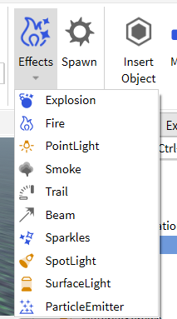
After adding, the effect will become a child element of the selected object in the Explorer hierarchy.
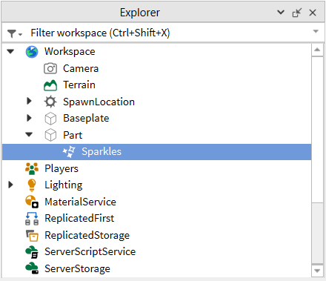
After adding an effect, you can click on it in the Explorer to access its properties. This allows you to fine-tune the effect by changing parameters such as color, intensity, duration, and so on.
Effects:
Fire: This effect creates the illusion of flame.
- Color: Sets the color of the fire.
- SecondaryColor: An additional color that blends with the primary one.
- Size: Adjusts the size of the fire animation.
- Heat: Controls the intensity of thermal radiation, affecting surrounding objects.
SpotLight: This is a directional light source that illuminates only a specific area.
- Color: Sets the color of the light beam.
- Brightness: Adjusts the intensity of the light.
- Range: Defines the distance the light extends.
- Angle: The angle of the light beam's spread.
- Face: Determines the direction of the light beam.
PointLight: A light source that illuminates all directions around itself. Excellent for creating atmosphere.
- Color: Sets the color of the light.
- Brightness: Controls the intensity of the light source.
- Range: Sets the radius of the light's effect.
Smoke: The Smoke effect creates a cloud of smoke around a specified object.
- Color: The color of the smoke.
- Opacity: The transparency of the smoke.
- Size: The size of the smoke particles.
- RiseVelocity: The speed at which the smoke rises upwards.
Trail: The Trail effect leaves a trail behind a moving object.
- Color: The colors of the trail's beginning and end.
- Lifetime: The duration of the trail in seconds.
- MinLength: The minimum length of the trail.
- Width: The width of the trail at the beginning and the end.
Sparkles: The Sparkles effect creates sparkles around an object.
- Color: The color of the sparkles.
- SparkleColor: An additional color for the sparkles.
- Number: The number of sparkles.

Advanced Tools: Union, Subtraction, etc.
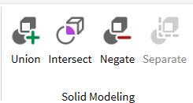
In Roblox Studio, there are tools for more complex work with 3D objects. These tools allow you to create unique shapes by combining and modifying basic 3D objects.
Union
- How to use: Select two or more 3D objects, then click the "Union" button on the "Model" tab.
- What it does: Combines multiple objects into one, creating a new complex object.
- Application: Useful for creating complex structures from simple shapes.
Intersect
- How to use: Select two intersecting objects and choose "Intersect" on the "Model" tab.
- What it does: Leaves only the part that intersects between both objects.
- Application: Used for creating new shapes by identifying common parts between objects.
Negate
- How to use: Select the object you want to subtract, then click "Negate". Then combine it with another object using "Union".
- What it does: Transforms the object so that when combined, it subtracts from another object.
- Application: Useful for creating holes, slots, or other complex shapes.
Separate
- How to use: Select an object created using "Union," "Intersect," or "Negate," and then click "Separate."
- What it does: Breaks the combined or modified object back into its original parts.
- Application: Used for correcting or further editing complex objects.

Independent Work: Experiments (10-15 minutes)
After mastering various tools and techniques in Roblox Studio, students have an excellent opportunity to apply their newly acquired skills in practice. In this part of the lesson, the task is to continue creating an obstacle course using all the knowledge and tools that have been discussed.
Task for Children:
- Adding new obstacles: Use basic shapes and advanced tools to create new and interesting obstacles.
- Modifying existing elements: Try applying tools for union, subtraction, or intersection to make existing obstacles more complex or interesting.
- Changing appearance: Don't forget about the options for changing color, material, and adding effects to improve the look of your obstacle course.
- Testing: After completing the work, conduct a test of your obstacle course. This will help you understand how interesting and functional it is.
This stage not only helps to reinforce the material but also develops students' creative thinking, allowing them to independently apply their acquired knowledge in practical activities.

Feedback Session (5 minutes)
At the end of the lesson and after completing independent tasks, it's important to get feedback from the students. This not only helps to understand what was most useful and interesting for them but also identifies areas that may need improvement or further explanation.
Idea for Conducting the Session:
Positive Moment: Ask the children to take turns sharing what they liked the most about the lesson. It could be a specific tool, effect, or simply the overall approach to teaching.
Area for Improvement: Also encourage students to express what they didn't like or what they think needs improvement. This could be the complexity of the material, the pace of teaching, or some technical aspects.
Summary: After everyone has spoken, summarize the discussion. Note general trends in the feedback and discuss what changes or improvements could be made in future lessons.
The feedback session is a valuable tool for the teacher, as it provides specific information on how the lesson was received by the students. It can also be a motivating factor for the children, as they see that their opinions are being considered.

Homework (5 minutes)
At the end of the lesson, students will have an interesting and creative homework assignment that will allow them to reinforce the skills they have learned and explore new possibilities.
Assignment:
The aim of this assignment is to experiment with the tools and techniques studied in the lesson. Your task is to create a scene on a specific topic. Topics can be varied, from unicorns and ponies to robots and cars. Choose what you like the most!
Instructions:
- Open Roblox Studio and create a new project.
- Use tools to add objects, change their appearance, and also add various effects.
- Try to apply different tools to modify the shape and size of objects.
- Experiment with various materials and colors to create a unique atmosphere.
- Save your project and, if you wish, share it in the next lesson.

